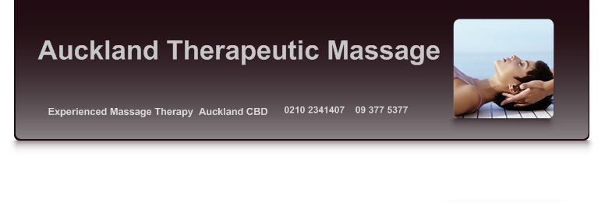
Gift voucher

1 hour Therapeutic massage (sample)

Auckland Therapeutic Massage @ Auckland City Chiropractic level 9 12-26 Swanson st Auckland CBD
09 377 5377 02102341407 info@aucklandtherapeuticmassage.co.nz www.aucklandtherapeuticmassage.co.nz Valid to 1st March 2014

